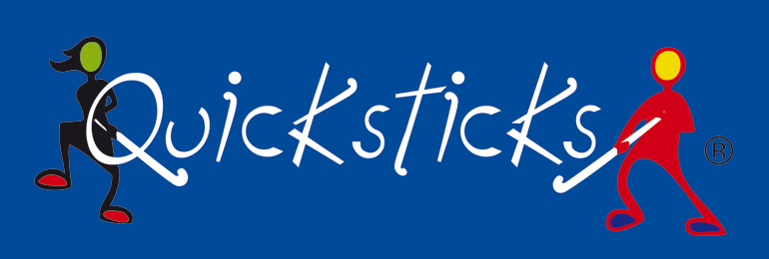
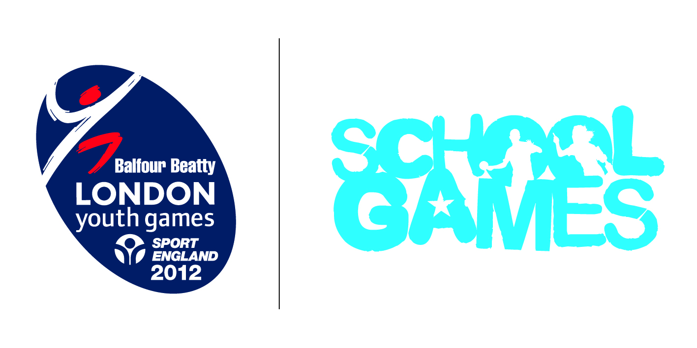

Wandsworth School Games Quick Sticks Festival

Quicksticks is England Hockey's brand new game designed specifically for Primary Schools and is aimed at 7-11 year olds.

Rules
- A team consists of six players: four outfield pitch players and two ‘Officials’ (one Manager/Coach and one Umpire).
- There are NO Goalkeepers in Quick Sticks
- Players rotate their positions at the end of each half
- Teams should be mixed with 2 boys & 2 Girls on pitch at all times
- Games will last for 2 x 4 minute periods
- There will be a minute for half time rotations
- Games are started with a centre pass

Goals
- Goals can be scored from inside the shooting area
- A goal is scored when the ball is struck completely over the goal-line & into the goal
- A penalty goal will be awarded if a defending player deliberately stops a ball from crossing the goal-line with their feet or body.
- The game will restart with a centre pass taken by team conceding goal

Free Pass
- A free-pass is given when the ball goes out of play or an offence occurs
- It must be taken from where the offence took place.
- Opposing team must be 3 metres away from the ball.
- After touching the ball, the free-pass taker cannot touch the ball again, until it has been touched or played by another player.

A free-pass is awarded when:
- The ball passes completely over a side line = Free pass to team which did not touch the ball last,
- The ball passes completely over the back line and was last touched by an attacker = The free-pass should be taken by the defending team from top of the shooting area. Attacking team must retreat to their defending third of the pitch.
- The ball passes completely over the back line and was last touched by a defender.
- The free-pass shall be taken by the attacking team from the corner of the pitch nearest to where the ball crossed the line (this case is similar to a corner ball in football).

And where a player:
- Kicks*, propels, picks up, throws, or carries the ball

(*Note: It is not an offence if the ball touches a player’s foot and the whistle should only be blown if the incident breaks down play or creates a disadvantage. The umpires must be the judge.)

Players will be penalised for the following offences:

- Intentionally uses any part of their body to play the ball.
- Attempts to play at any high ball (over knee height) with the stick.
- Uses the rounded (back) side of the stick.
- Whilst striking the ball, causes any actual or possible danger to themselves or to other players.
- Obstruct another player with their body or stick
- Holds, charges, kicks, pushes, intentionally trips or strikes any player or umpire.
- Interferes with another player’s stick or clothing
- Plays the ball dangerously or in a way which leads to dangerous play.
- Rough or dangerous play

(*Note: The overall Match Officials shall send any player who persists in breaking this rule off the pitch for a two minute suspension in the sin bin. For the duration of a temporary suspension, the offending team plays with one player less.)

Result
The team scoring the most goals is the winner; if no goals are scored, or if the teams score an equal number of goals, the match is drawn.

Format

The tournament will in a round robin format with each team playing the others
3 points for a win & 1 point for a draw
The team with the most points at the end of the fixture will be deemed the winners
If points are level, the positions will be decided on goal difference & then goals scored

Kit/Equipment
Players can either use their own hockey sticks or the Quicksticks provided
Players are encouraged to wear shin pads and gum shields when playing Quicksticks. Those who do not wear these protective pieces of equipment do so at their own risk.

