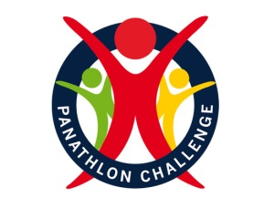

Primary Panathlon Rules
*Primary Panathlon runs on a rotational system whereby students get to take part in each of the 8 activities for 10 minutes.

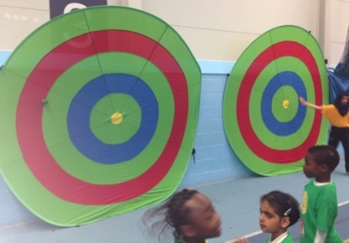
Flight Path
- 1 person at a time (per target).
- Students throw Velcro balls at target from 1.5m away, 1m for wheelchair users.
- 5 shots each then rotate student (continue for 10mins).
- 1 point every time the ball is thrown and sticks on the inner two rings (green and yellow ring)
- Teams points are added together.

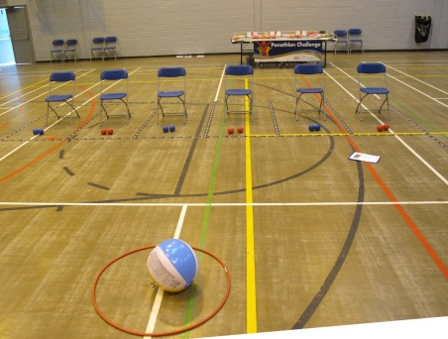
Boccia Blast
- All students must be sat on chairs in a line.
- Students take it in turns to throw a boccia ball at the beach ball.
- The beach ball and hoop should be placed 2m from students sat down.
- Each time the beach ball is hit out of the plastic hoop, the team score 1 point.

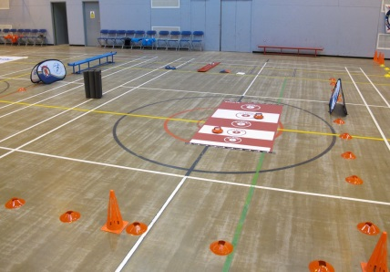
New Age Kurling
- 1 person at a time
- 3 shots each then rotate students (continue for 10mins)
- Students try to slide kurling stones on to the scoring target
- Students slide from a marked area which is 2m away from the target area. This can be varied, depending upon floor surface.
- Take the highest score from the team over the 10 mins.
Parachute Popcorn
- Students stand spread out around the outside of the parachute, holding a part of the parachute and begin to shake it.
- Once the parachute is shaking the teacher/ leader can add 30 balls.
- The balls fly off the parachute and then the children are timed to collect all balls back in (putting in to a bucket).
- Do this intermittently for 10 mins allowing students to rest in between.

Table Cricket
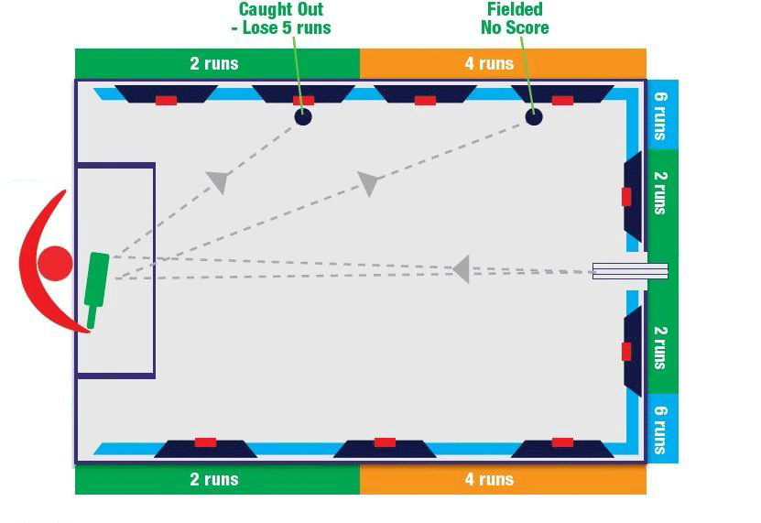
- Involves 2 players at a time, 1 batter and 1 bowler.
- Other students stand around the outside of the table and rotate with batter and bowler.
- Each student has 6 bats and 6 bowls (time depending)
- Bowler rolls the ball down the ramp and then batter hits the ball against the side of the table (aiming for the scoring targets- 6,4 and 2)
- If a player misses the ball they score 0
- If ball is hit off the table it counts as -5 runs.
- If they hit the ball to a fielder target they score -5 runs.
- The teams score is added together.

Volleybat
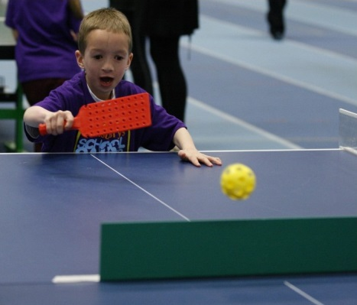
- Students rally up and down the table tennis table.
- The ball must stay on the surface of the table.
- The ball may hit the side of the table but if it hits the barrier in the middle of the table, the rally breaks down.
- Rotate children after each rally
- The highest rally for the team is recorded.
- If the rally reaches 40, then the rally should be stopped and children rotate. Max score is 40.

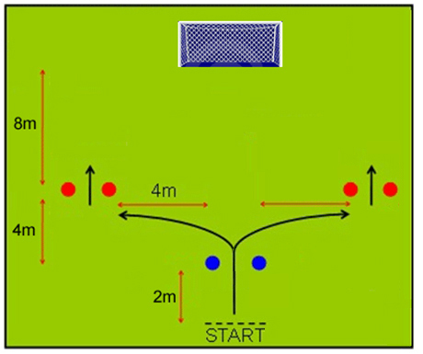
Messi Football
- Dribble the ball through the blue cones and then through red cones (either right or left side is fine).
- Once through the red cones, the student may shoot the ball at the goal.
- Every goal is recorded for the team.
- Wheelchair users may hold the ball in hands and throw rather than kick.

Precision Beanbag
- 1 student at a time (rotate students)
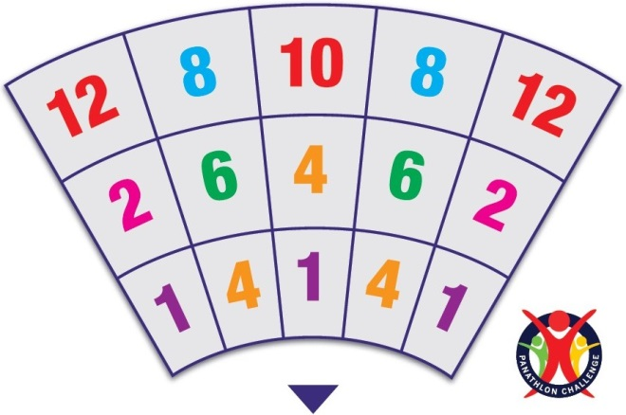
- Player is seated
- 6 beanbags to throw at numbered target mat
- Each beanbag must go in to a different target area (eg if 2 beanbags are thrown in the same box, only one counts.
- Take the score from where the beanbag finishes, not where it lands
- Highest score and lowest score from the team are added together to give the team score.

