The FA Primary Teachers Award
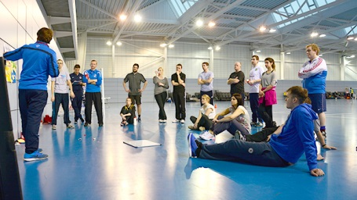

The FA Primary Teachers Award is a FREE course designed for any practicing or aspiring primary school teacher and it has been hugely successful in developing teachers’ confidence to deliver high quality PE.

The course presents ideas for lessons using games based around movement skills for 5–11 year olds and the basic principles of invasion games. The tutors show how differentiation and assessment for learning can be embedded in PE lessons and also give guidance to those teachers who might run a school team.

The course is applicable for those who wish to build on their existing knowledge and those with little confidence of PE or invasion games. The 6 hour course can be delivered in one day or across two 3 hours sessions.

Throughout the course, the tutors will also explain the importance of high quality PE in schools in order to develop confidence, self-esteem and belief amongst children and also the benefits of PE in raising academic achievement across other school subjects.

Candidates will gain a resource booklet and a recognised FA qualification on completion.

At the end of the course the learner will:

- Have a greater awareness of the contribution of invasion games have to KS1 & 2 PE purpose of study
- Understand The FA’s playing and coaching philosophy (England DNA)
- Understand how to set up an organised football or invasion game activity session
- Understand how to organise basic FUNdamental games to help develop Physical Literacy
- Have an understanding of how to modify practices to manage difference
- Understand how to set up 4v4 games for young players
- Have an understanding of how to further their knowledge and understanding of association football through attending relevant courses

For Universities, Schools or Partnerships wishing to host the delivery of an FA PTA. The 6 hour course can be delivered in one day or across two 3 hours sessions. Although it is completely free, you would need to find a suitable venue (ideally a sports hall) to host the course. The majority of the delivery is practical and course numbers can be anything in excess of 12.

The course may be delivered to individual schools, individual school sports partnerships or within a cluster of SSP’s. For more information, please contact Lawrence Lok – lawrence.lok@thefa.com or 07966894500

Testimonials

Very useful activities which can be used throughout PE curriculum

Really enjoyable but also a great learning experience as we set up equipment, differentiated ourselves and saw new teaching strategies.

Showed clear progression strategies, understood our ability and confidence level and tailored sessions to suit. Fun and interactive.

I like that it was always related back to schools. Really good emphasis on AFL, everyone always had an active role.

Inspiring and encouraging teaching, strong pedagogical knowledge and holistic approach to education.

We learnt practical skills to develop in football. We progressed in skills throughout the sessions. We learnt as children as well as teachers.

Developed my understanding of football, presented me with some games and activity ideas. Considered all sports and pedagogical ideas.

Made football accessible to us all, made us feel engaged and valued. Also linked how you related to other sports/pedagogy.

Lots of ideas and teaching strategies to use.

It gave me ideas for inclusion in PE, inspiration, motivation and confidence. Showed clear progression and key skills.

I liked the different variety of games to build up progression and could be used in different sports.

Progression of practical learning activities, games / creativity of activities. Timings of activities.

It gave me much more confidence in using ball/football and general PE/teaching.

Lots of ideas to take away with me.

Clear instruction, great subject knowledge - related it to aspects of teaching.

