Physical Education, Sport and Wellbeing - Websites
Youth Sport Trust | Youth Sport Trust have created some easy to follow activity cards with fun challenges and PE activities for children at home. The aim is to help parents/carers bring the ideas to life within their home environments (inside or outside) – and can be adapted to suit a range of ages abilities.  https://www.youthsporttrust.org/free-home-learning-resources-0
Topsportsability  Inclusive PE & Sport | Fantastic online resource of Inclusive PE & Sporting activties and ideas for young people with Special Educational Needs & disabilities. Free at https://www.topsportsability.co.uk/  Sign up using the Inclusion Lead Code: YSTINCLUSION25
FA Girls Football in Schools | A fantastic website to access resources, ideas, useful information and links to help you grow girls’ football.  https://www.girlsfootballinschools.org/
Real Play by  Create Development | Create Development’s real play at home supports families to play and learn together and includes 12 themes, 6 areas, over 250 activities and challenges, of fun and activity for every family!  Email jasmine@createdevelopment.co.uk for further information.  https://vimeo.com/398010428
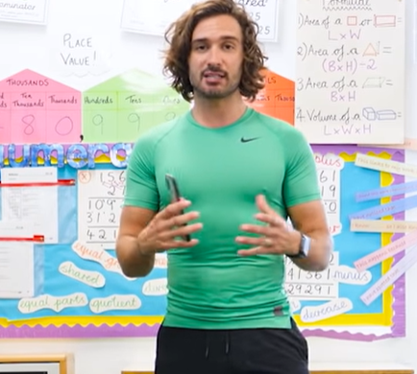 | Age range: KS1 and KS2  Joe Wicks will be conducting daily PE lessons for children of primary age at 9am each day during the school closure. Visit his YouTube channel:  https://www.youtube.com/watch?v=K6r99N3kXME
Andy’s Wild Workouts -BBC iPlayer | Age range: EYFS, KS1  Andy travels the world to amazing places and learns to move like the animals he meets on his wild adventure.  https://www.bbc.co.uk/iplayer/episodes/p06tmmvz/andys-wild-workouts
Age range: KS1 & KS2
Premier League Primary Stars have created activities covering English, Maths, PE, Health and Wellbeing. https://plprimarystars.com/news/home-learning-activities-school-closures
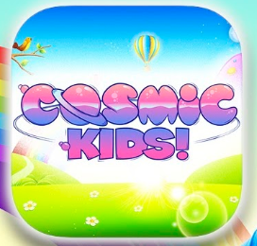 | Age range: EYFS, KS1 and KS2  Yoga, mindfulness and relaxation videos.  https://www.youtube.com/user/CosmicKidsYoga
Age range: KS1 and KS2
Just Dance is a YouTube channel featuring guided dancing sessions to popular songs.
https://www.youtube.com/watch?v=RefJ2QOsVLo
Age range: EYFS, KS1 and KS2
Movement mindfulness and relaxation videos
https://www.gonoodle.com/good-energy-at-home-kids-games-and-videos/
Chance to Shine Cricket | Chance to Shine provides cricket and class room based activities for teachers and parents/carers. These are free on the Resource portal: https://teachers.chancetoshine.org/s/login/?ec=302&startURL=%2Fs%2F
BBC Supermovers | Super movers - https://www.bbc.co.uk/teach/supermovers

